Active Directory Integration with ServiceNow
Submitted by: - Sandeep Kumar and Sachin Saini
In this we are going to use public source (Name: - FORUMSYSTEMS) LDAP URL

1. Overview

Integrating LDAP (Lightweight Directory Access Protocol) with ServiceNow allows you to manage user authentication and import user and group information from your organization's LDAP server, such as Microsoft Active Directory and we only have read-only-accessed This integration simplifies user management and ensures consistent access control.

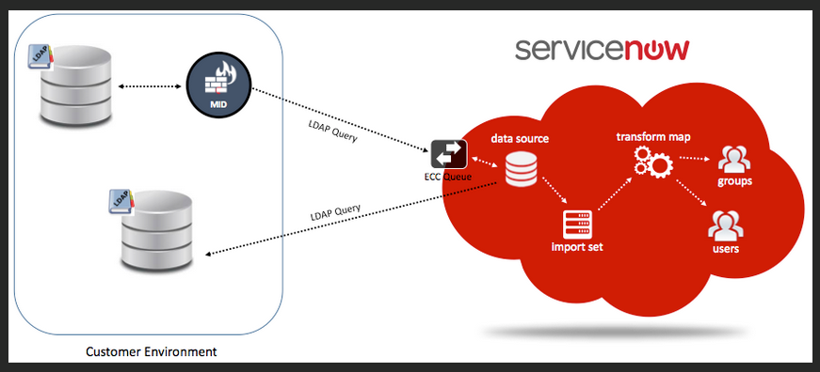

2. Requirement

ServiceNow Access: Administrator-level access to your ServiceNow instance.
LDAP Server: A working LDAP server (e.g., Microsoft Active Directory or OpenLDAP).
LDAP Credentials: Administrator credentials for the LDAP server.
Access: ServiceNow can connect to our LDAP server over the network.

3. Setting Up LDAP in ServiceNow
Creating an LDAP Server

- Access LDAP Servers:
Go to System LDAP > LDAP Servers in the ServiceNow menu.

- Add a New LDAP Server:
Click New

Here we must fill the all required details and submit it: -

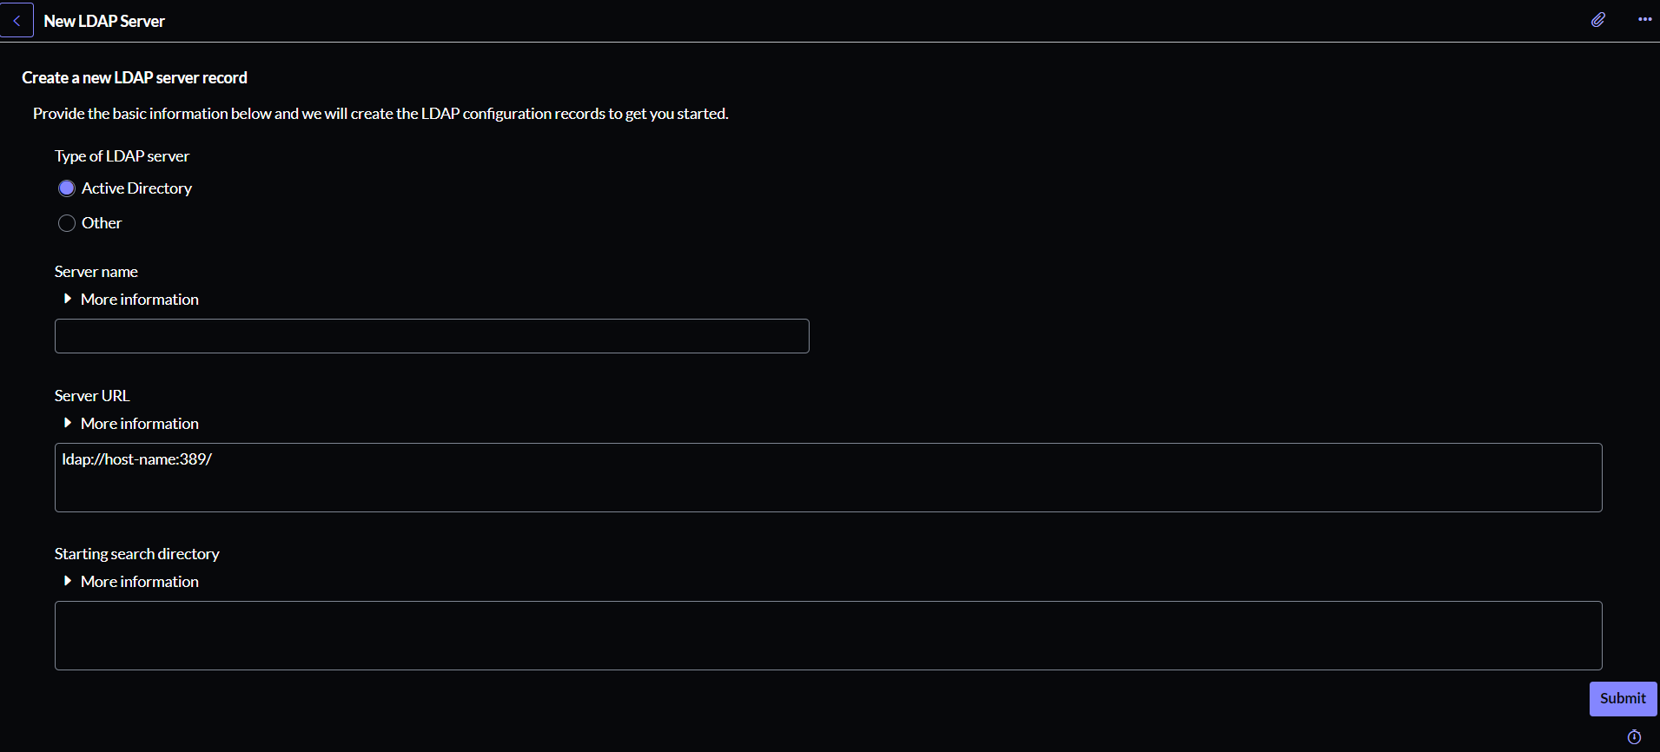

Name: A descriptive name for the LDAP server.
Server URL: The LDAP server URL (e.g., `ldap://ldap.forumsys.com`).
Use secure connection: Check this box if using LDAPS (LDAP over SSL).

Configuring LDAP Server
- Set Up Connection Details:
    - Bind DN: The distinguished name of the LDAP account used to connect.
    - Bind Password: The password for the Bind DN.
    - Test Connection: Use the Test Connection button to ensure the settings are correct.

2. Configure LDAP Query:
Set the base DN (e.g., `dc=example, dc=com`).
Define the search scope and filters to retrieve the desired entries.

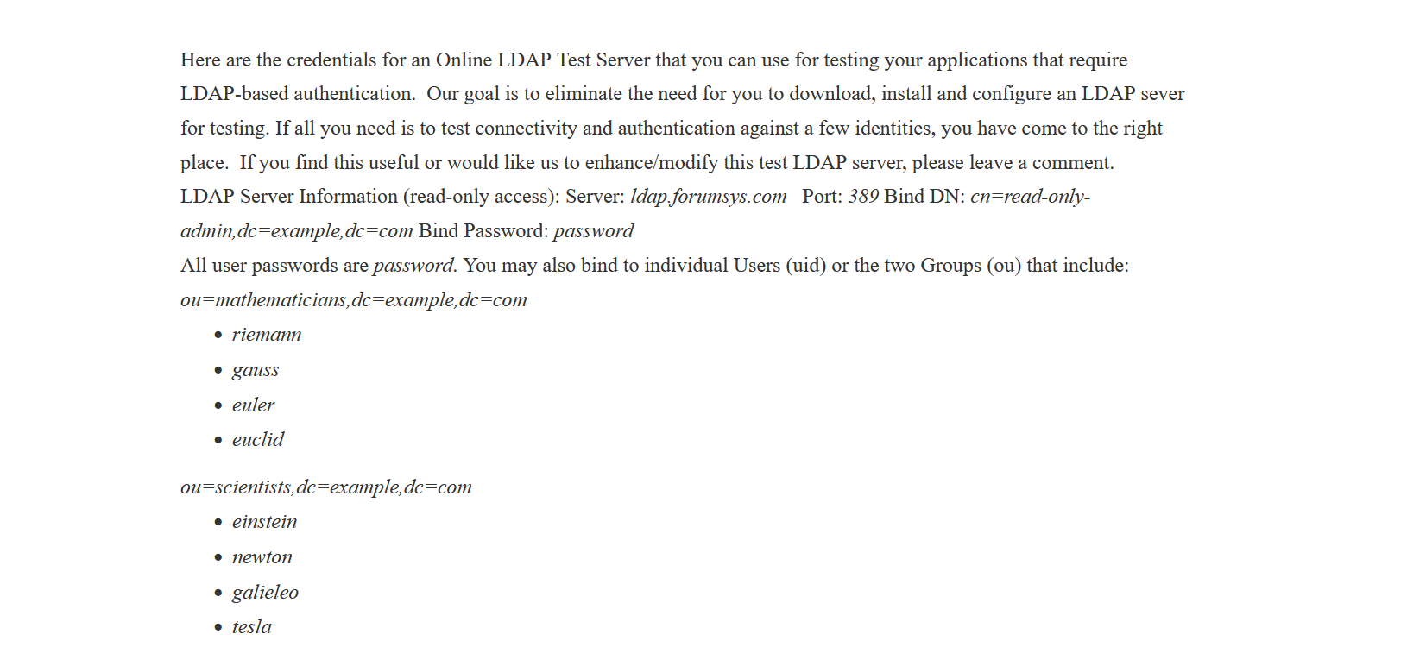

After submitting this we will get this new window.

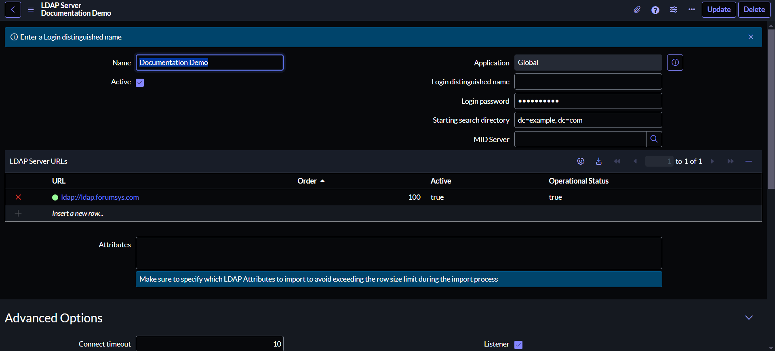

4. Now we must put login distinguish name and details to import the users and groups.
Defining LDAP OU Definitions

Now we have to put the login user name and password so the ServiceNow can login to the LDAP Server.
So we will go to the same site and their we can check the distinguish name and password.
DN: - “cn=read-only-admin,dc=example,dc=com”
Password: - “password”
And then we need to save it and we can see the pop-up (Connected Successfully).

And then we need to save it and we can see the pop-up (Connected Successfully).
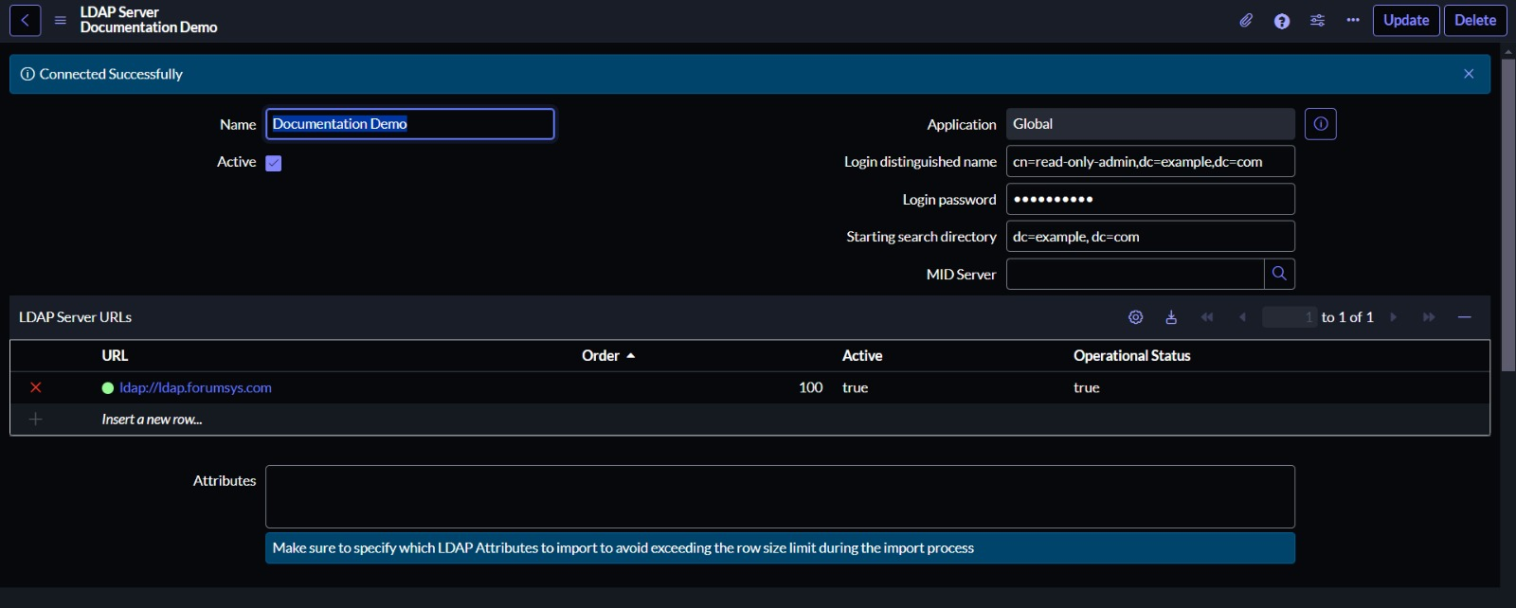
Note: - If you want to check it again if this is connected or not then you can see in below of the form there is an option “Test Connection”, so you need to click on this and you can check your connection again and if you created it first time then it will always check automatically.

LDAP basically have lot of attributes or lot’s of column’s for user details such as User-ID, Name, email address and lots of things. In attributes we can also mention the specific column name which we only want to import.
Now in the bottom we can see their automatically created two OU definitions: -
- For Groups: -Groups[sys_user_group]
- Users: -Users[sys_user]

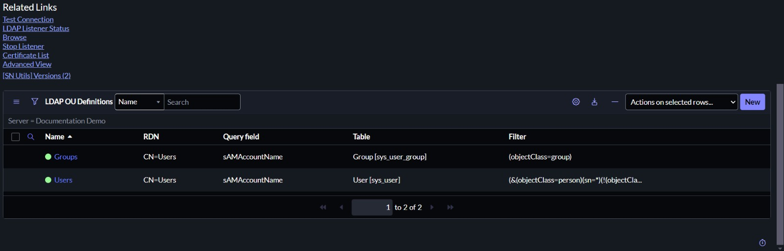

Now we need to check that we are able to see the users and groups.
Note: - LDAP filter: - It will decide what user you should pick from LDAP and put it into ServiceNow. (In LDAP we can also find the different type of users).

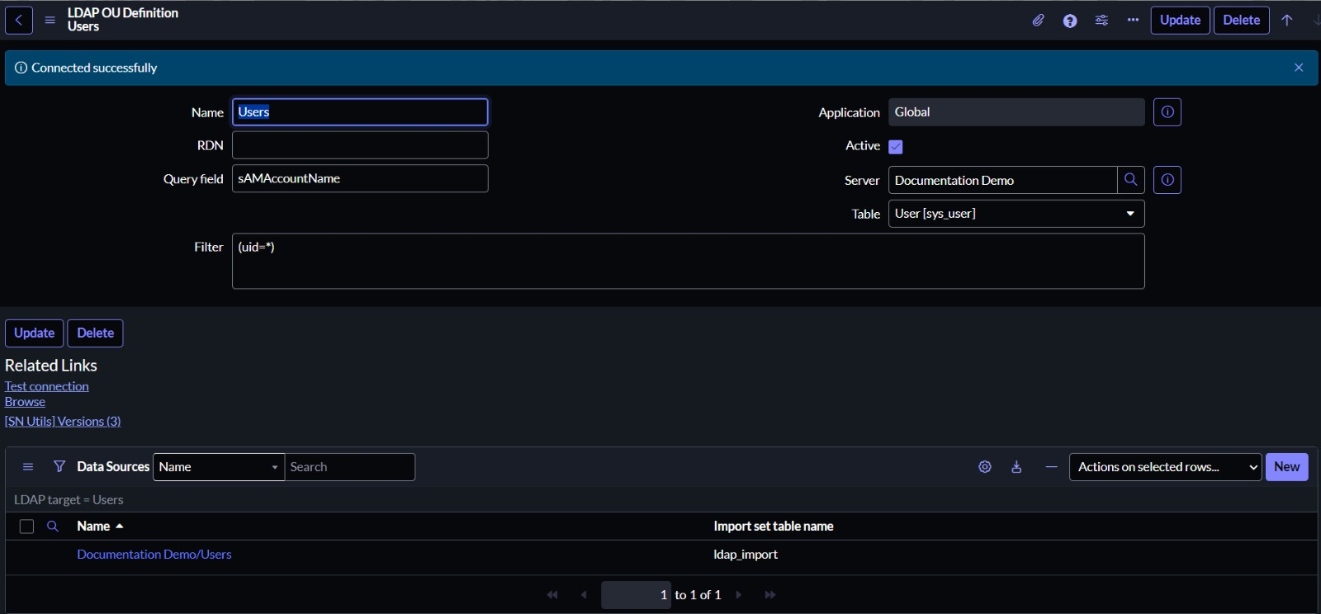

In filter we need to give the specified condition here I have used the (uid=*), now we can see all uid users list.

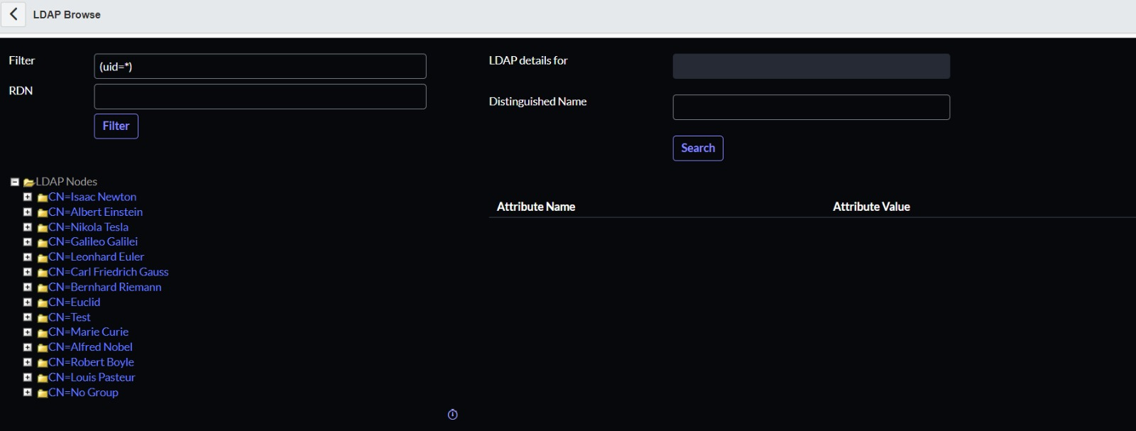

Now we need to check the User is created to not in our user table: -
These users are created in our User List.
